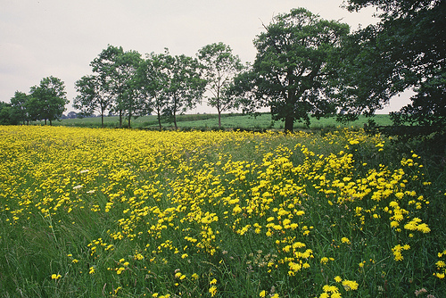

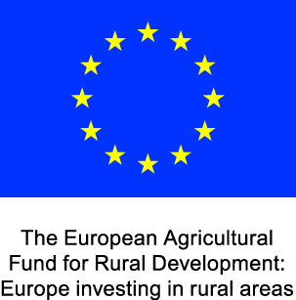Defra Logo 4Col.eps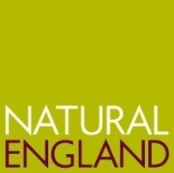

Name: Ian Waller

Region/County: South East/ Buckinghamshire

Address: Hampden Bottom Farm, Rignall Rd, Great Missenden, Bucks, HP16 9PT

Farm Si Farm size/Type: 440 hectare arable unit

Cropping: Milling wheat, winter oilseed rape and spring beans on rotation

Stocking: 35 Herdwick ewes and 22 followers for conservation grazing

Land fe Land Features: enclosed small valleys, large scale rolling hills and plateaux, extensive area of beech woodland. Grim’s ditch - nationally important monument

Key objectives: The inclusion of areas of chalk grassland within the arable field pattern; the creation of species-rich chalk grassland; the maintenance and enhancement of existing habitat for birds; restoration of hedges; establishing lapwing habitat; protection of nationally important Grim’s Ditch and Dene Hole from further damage from arable cultivations and the creation of arable filled margins for rare annuals.

**Ian Waller is a first generation arable farmer with a passion for improving and promoting farm wild life and heritage. Since taking the tenancy of Hampton Bottom Farm he has wanted to improve its nature conservation status. He felt unable to join the Countryside Stewardship Scheme (CSS) in the first few years of his tenancy as he needed to get the farm system organised.**

**He was ready when Entry Level Stewardship (ELS) was launched in 2005 and joined the scheme. This worked well for Mr Waller, and he applied for the Higher Level Stewardship (HLS) in 2006. He studied the options carefully and chose those that would fit in with the farming system and that would give him pleasure to implement.**

**Ian Waller says that it is down to his willingness to ‘gold plate’ the management for the options and the willingness of the Natural England adviser to be flexible in the implementation of the prescriptions.**

www.naturalengland.org.uk

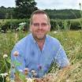**“Some prescriptions would not be as effective if I did not do some extra work. For instance clearing the dead stems of the nectar and pollen crops to promote growth the following year and sowing the different wild bird seeds at different times of the year rather than altogether so that they achieve their growth potential.”**

**A flock of sheep being introduced for conservation grazing on a commercial arable farm exemplifies his commitment to achieving nature conservation objectives.**

**Mr Waller has also added scrapes to his cultivated fallow plots as he noticed lapwing chicks feeding on insects in tramline puddles. This scheme option is targeted at suitable fields or in-field plots of a least 2ha, that are left uncropped with a proportion of the plot cultivated to produce rough fallow conditions. These conditions aim to provide breeding sites for lapwing, among other farmland birds. The same small area supports skylarks and brown hare populations.**

**Also to save the taxpayer great expense in fencing small reverting grassland fields for grazing, he purchased a forage wagon to ‘mechanically graze’ them,** which has led to an increase in plant & floristic diversity and reduction in grass species density, and a desirable reduced soil fertility in the absence of manure from sheep.

**This attention to detail and truly integrating ELS and HLS into the farming system so that it is based not on crop production but integrated crop and wildlife habitat management has resulted in a number of conservation awards for the farm, including winning in 2008 the south east regional award at Natural England’s Future of Farming Awards.**

**He was praised by the judging panel for his ‘innovative approaches to the management of the farm for biodiversity’, also stating that ‘his commitment to biodiversity in tandem with profitable commercial farming is specifically impressive. The fact that he advocates his approach and resultant successes so enthusiastically and to such a wide cross-section of industry, government and the public only strengthens his commitment and the impact of his efforts.’’**

**This agreement appears to be achieving its objectives, and more besides, because of the commitment and enthusiasm of the farmer and his Natural England adviser, Vicky Robinson, who often visits the farm in her own time.**

**“It has been incredibly rewarding working with Ian over the last 7 years. What he has achieved on his farm has been fantastic and he always goes over and above what is required. It makes my life a lot easier knowing that what needs to be done gets done and to an exceptionally high standard. I feel we have a great working partnership and fully understand where each other are coming from. The results speak for themselves.”**

**Where can I find out more?**

For more information about Environmental Stewardship please read [Look after your land with Environmental Stewardship[external link](http://publications.naturalengland.org.uk/publication/31048?category=45001)](http://publications.naturalengland.org.uk/publication/31048?category=45001)